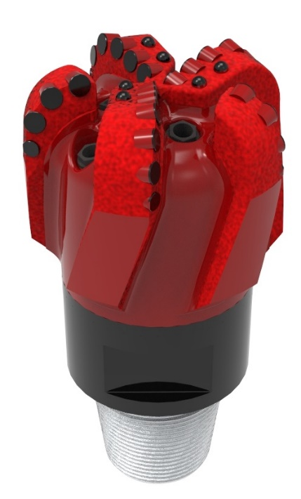

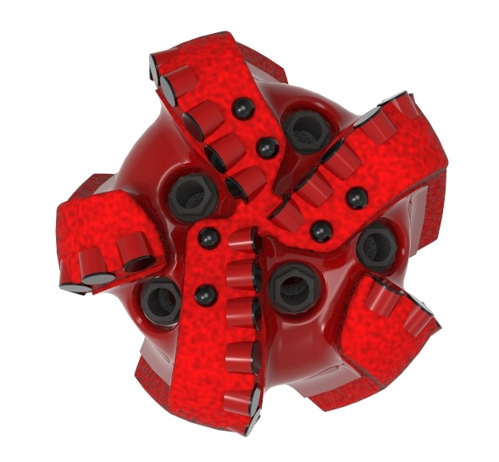

Drill Bit Specifications:
Cutter Size (Primary, Sec) | 5/8”,1/2”
Cutter Count (Total, Gage) | 28,6
Blade Count | 5
Gage Length (Inches) | 3.00
Nozzle Count (Primary, Sec.) | 5
Nozzle Series (Primary, Sec.) | 60
JSA (Sq. Inches) | 10.84
Max. TFA (Sq. Inches) | 1.86
Operating Parameters:
Max. Weight on Bit (1,000 Lbs.) | 60
Make-up Torque (ft/lbs) | 17,399
Nominal Dimensions:
Overall Length (Inches) | 14.61
Make Up Length (Inches) | 10.49
Bit Breaker | SKB-21010
Connection | Ø4-1/2" API Reg.
Approx. Weight (Lbs.) | 95

Standard Features:

- Premium grade cutters maximize
ROP and Life
- Large open face volume assists cuttings removal
- Five nozzles optimize blade cleaning and cuttings removal

516-SR(K) Nomenclature Explained:
- 5 = Number of Blades
- 16 = Primary Cutter Size (16mm)
- SR - Single Row of Cutters

- K = Bullets

